

FACULTY OF COMPUTER SCIENCE AND MATHEMATICS

FUNDAMENTALS OF ALGORITHMS & COMPUTER PROBLEM SOLVING

CSC126

**SPORTS CENTER BOOKING MANAGEMENT SYSTEM**

PREPARED BY:

DURRANI AFIQ BIN SAIDIN

MATRIC NO:

2020769853

PREPARED FOR:

DR. MOHD. FAAIZIE BIN DARMAWAN

DATE OF SUBMISSION:

5 JULY 2020

**CASE STUDY**

Forum 19 Sdn. Bhd. requested for a badminton court booking management system. The application needs to be capable of getting the following user input:

* Date of reservation
* Time of reservation
* Duration of reservation
* Number of courts reserved
* Court selection(s)
* Customer name
* Customer NRIC
* Enabling student discount option for those who are eligible
* Amount of cash paid

The program needs to be capable of calculating and display the amount of fee needs to be paid by the customer based on the given information and rate:

Booking info and rates:

Monday - Friday:

Opens 8AM – 2AM

Day Rate 8AM – 6PM : RM10/hr

Night Rate 6PM – 12AM : RM20/hr

Midnight 12AM – 2AM : RM15/hr

Saturday – Sunday:

Opens 8AM – 2AM

1 hour : RM25

2 hours : RM45

3 hours : RM60

> 3 hours : RM60 + RM10/per additional hours

* Discount 20% off for students.
* Rates are calculated per court.
* Maximum of 5 courts allowed per booking.
* Maximum of 3 hours allowed for walk-in reservation.
* Walk-in reservation starts on the next hour from the current time.
* (eg. Booking at 10:21AM, Reservation starts at 11:00AM)
* Reservation is closed after 12:00AM
* RM10 deposit required for non-walk-in reservations.
* Price shown above are excluding SST.

The program will calculate the change based on the cash payment. The user will get the option if they want to print the receipt for the customer.

Features/Advantages:

* Make reservations for walk-in customers/other time or date
* Automatically calculate the reservation fee
* Printing the receipt for the customer
* View all and individual reservations
* View revenue report
* Clearing/cancelling individual or all reservations
* Reservation fee calculation can still be calculated even without the data files/folder

Disadvantages:

* The program is unable determine if the booking time and the court chosen are overlapping with other customer reservation.
* Reservation lists are not sorted accordingly

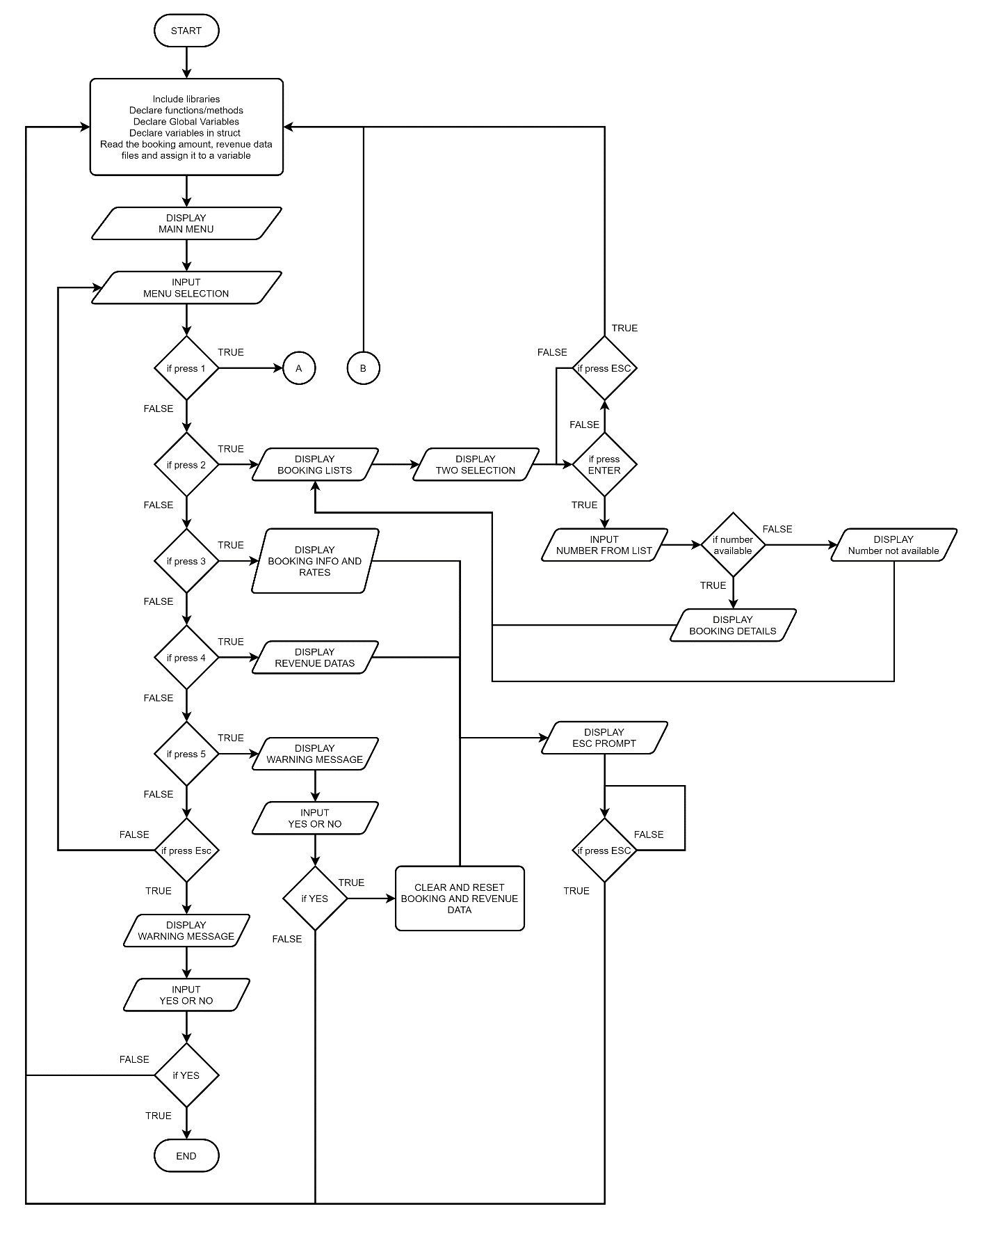**FLOWCHART (SIMPLIFIED)**

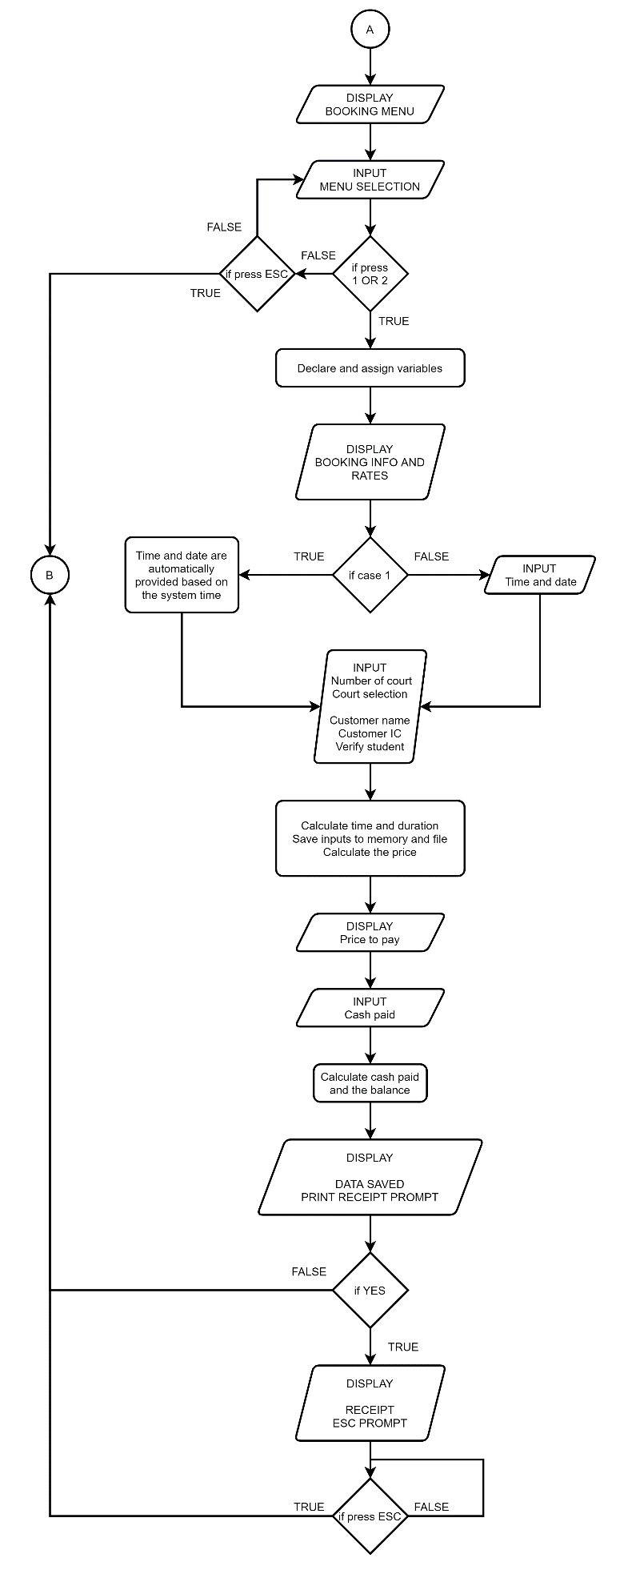

**FLOWCHART (DETAILED)**

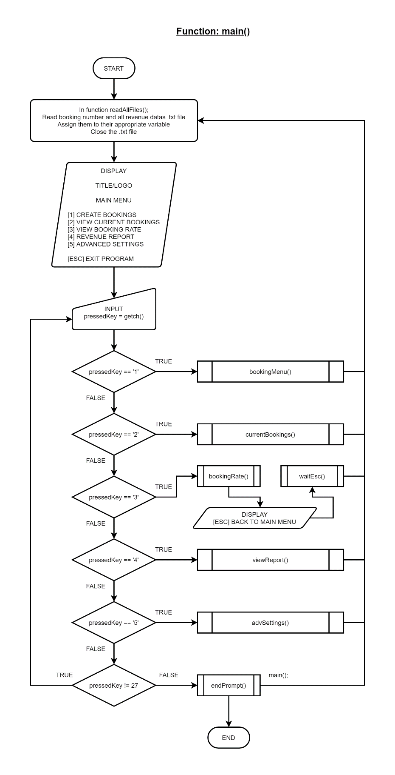Function: int main()

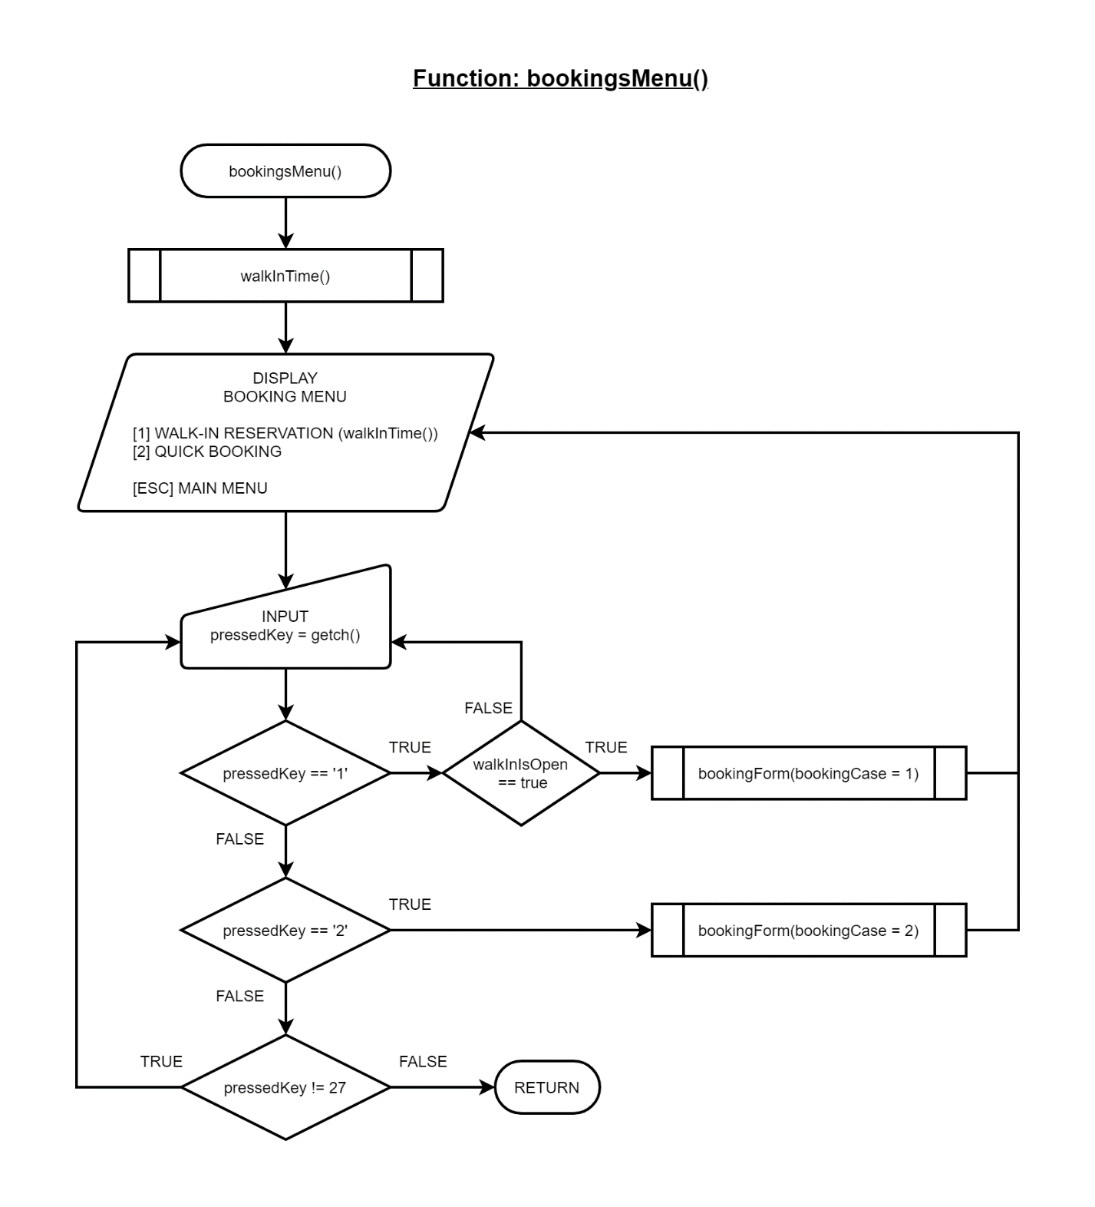Function: void bookingsMenu()

Function: string walkInTime()

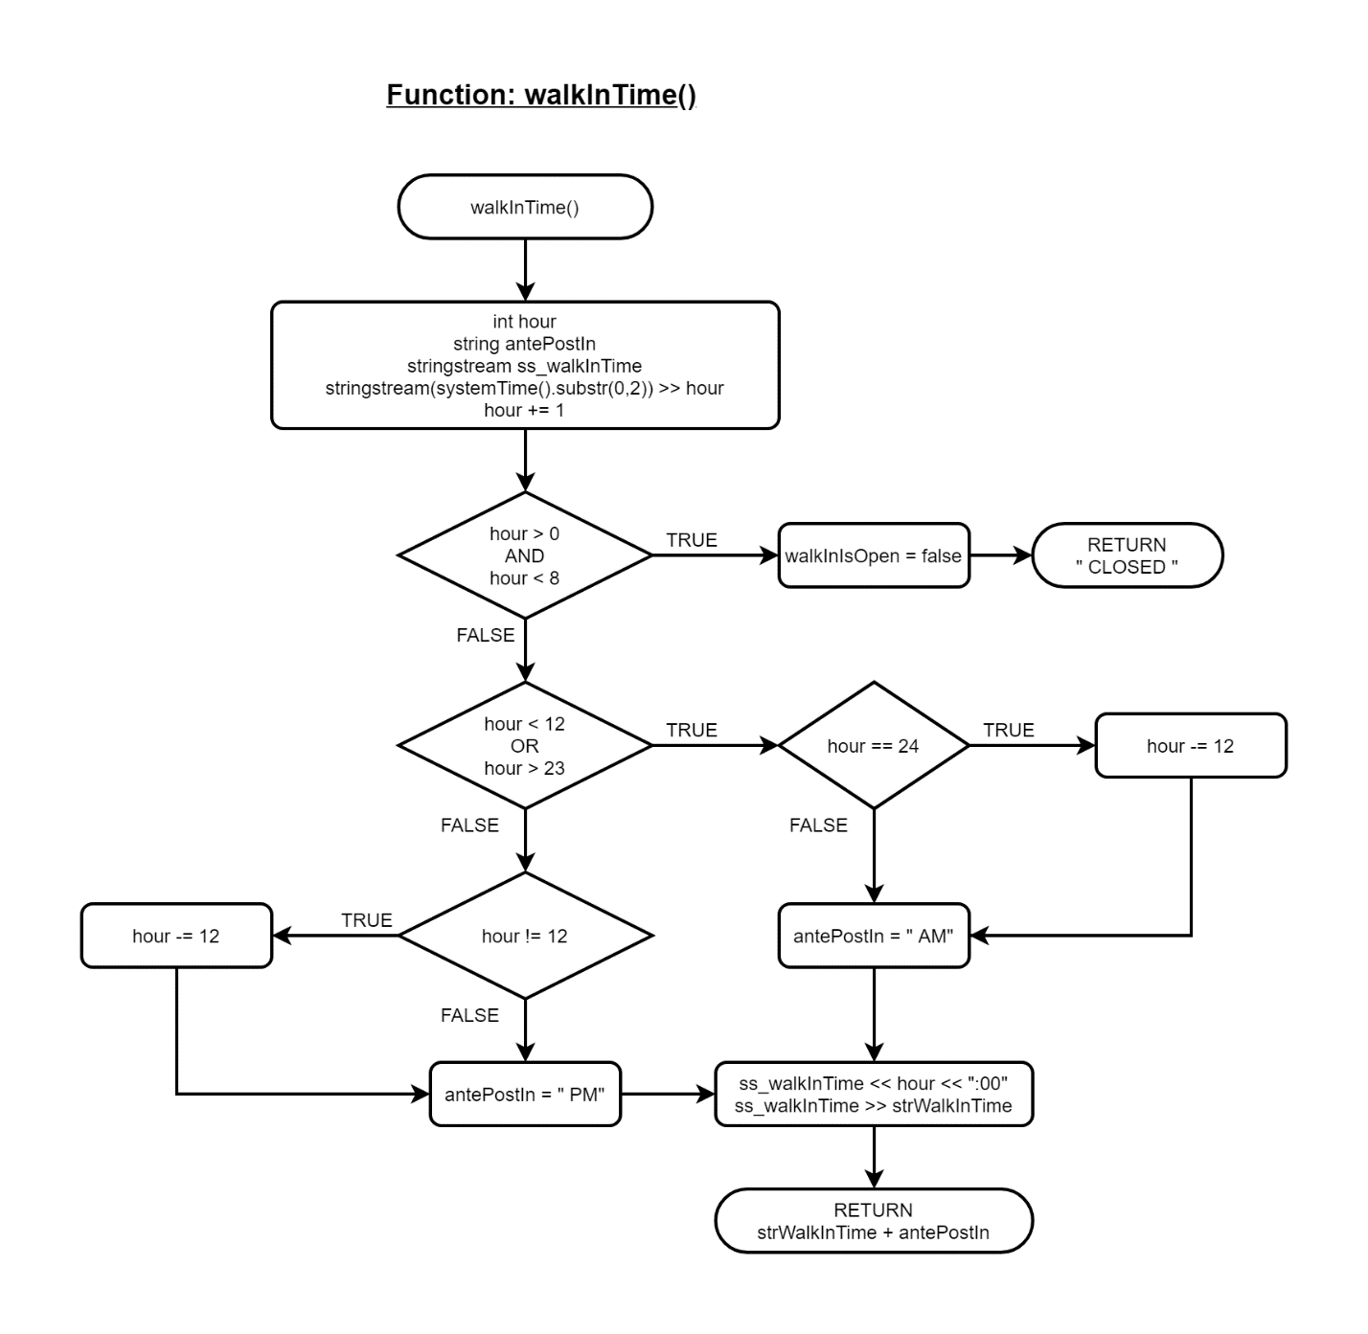

Function: void bookingForm(int& bookingCase)

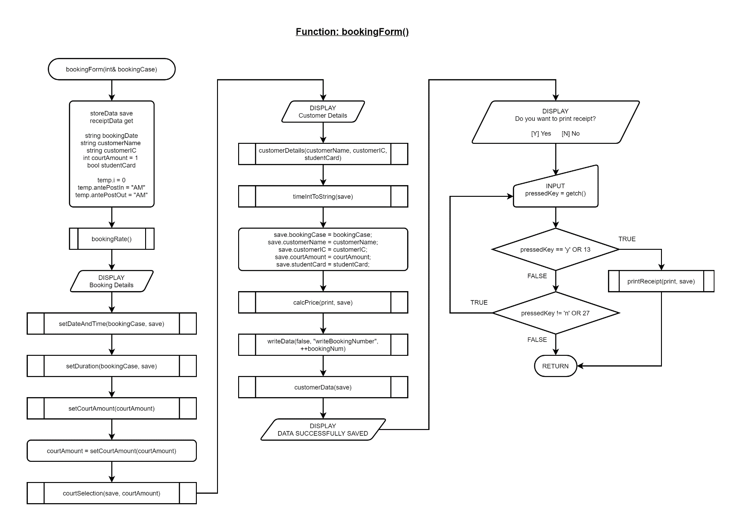

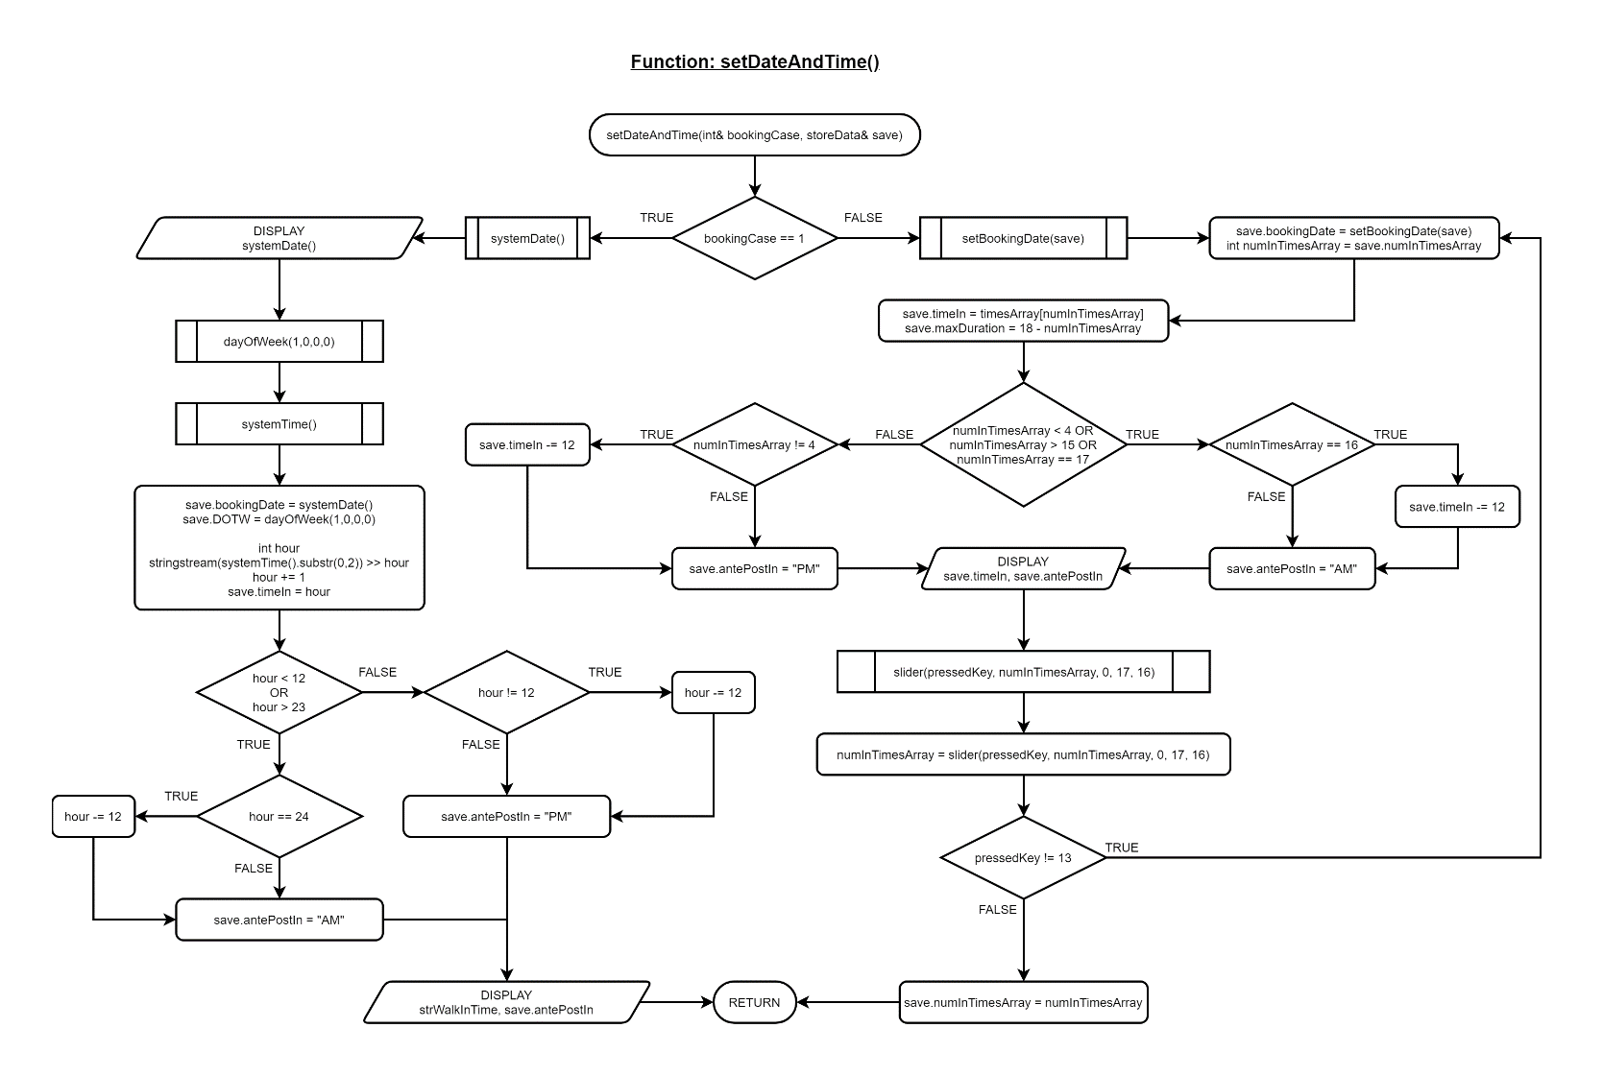Function: void setDateAndTime(int& bookingCase, storeData& save)

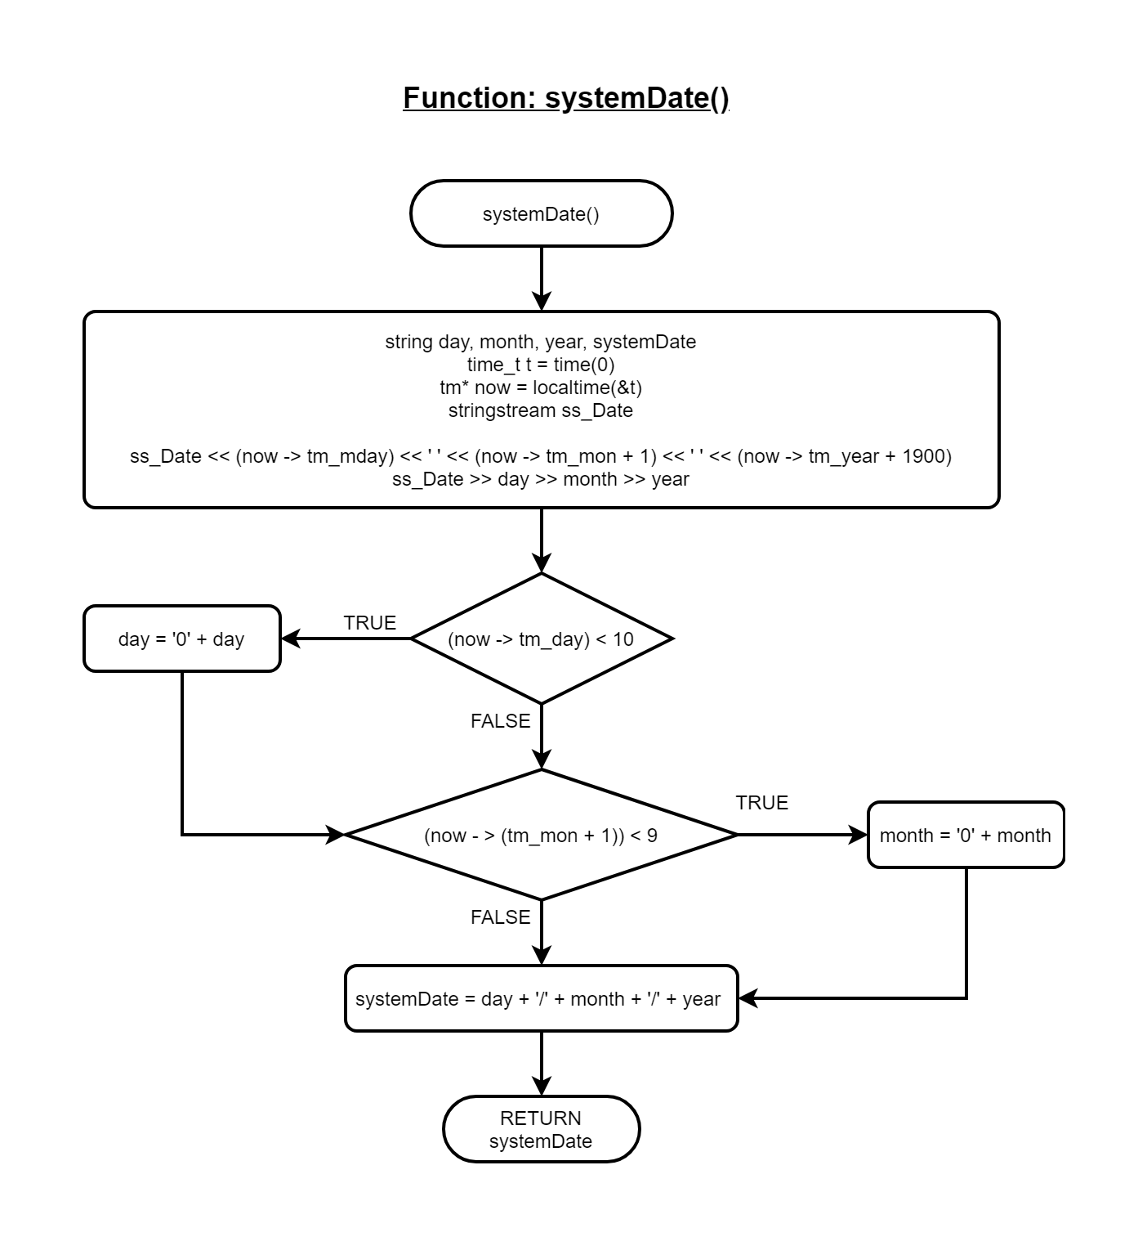Function: string systemDate()

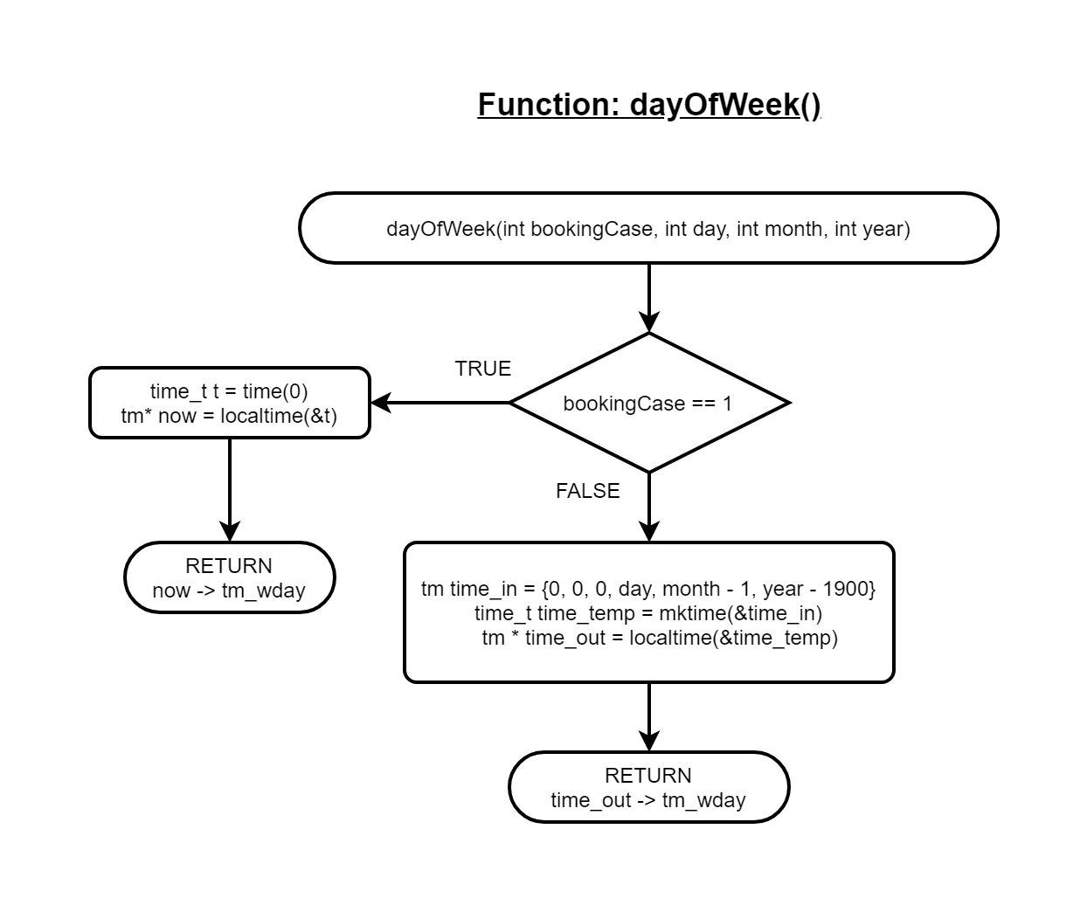Function: int dayOfWeek(int bookingCase, int day, int month, int year)

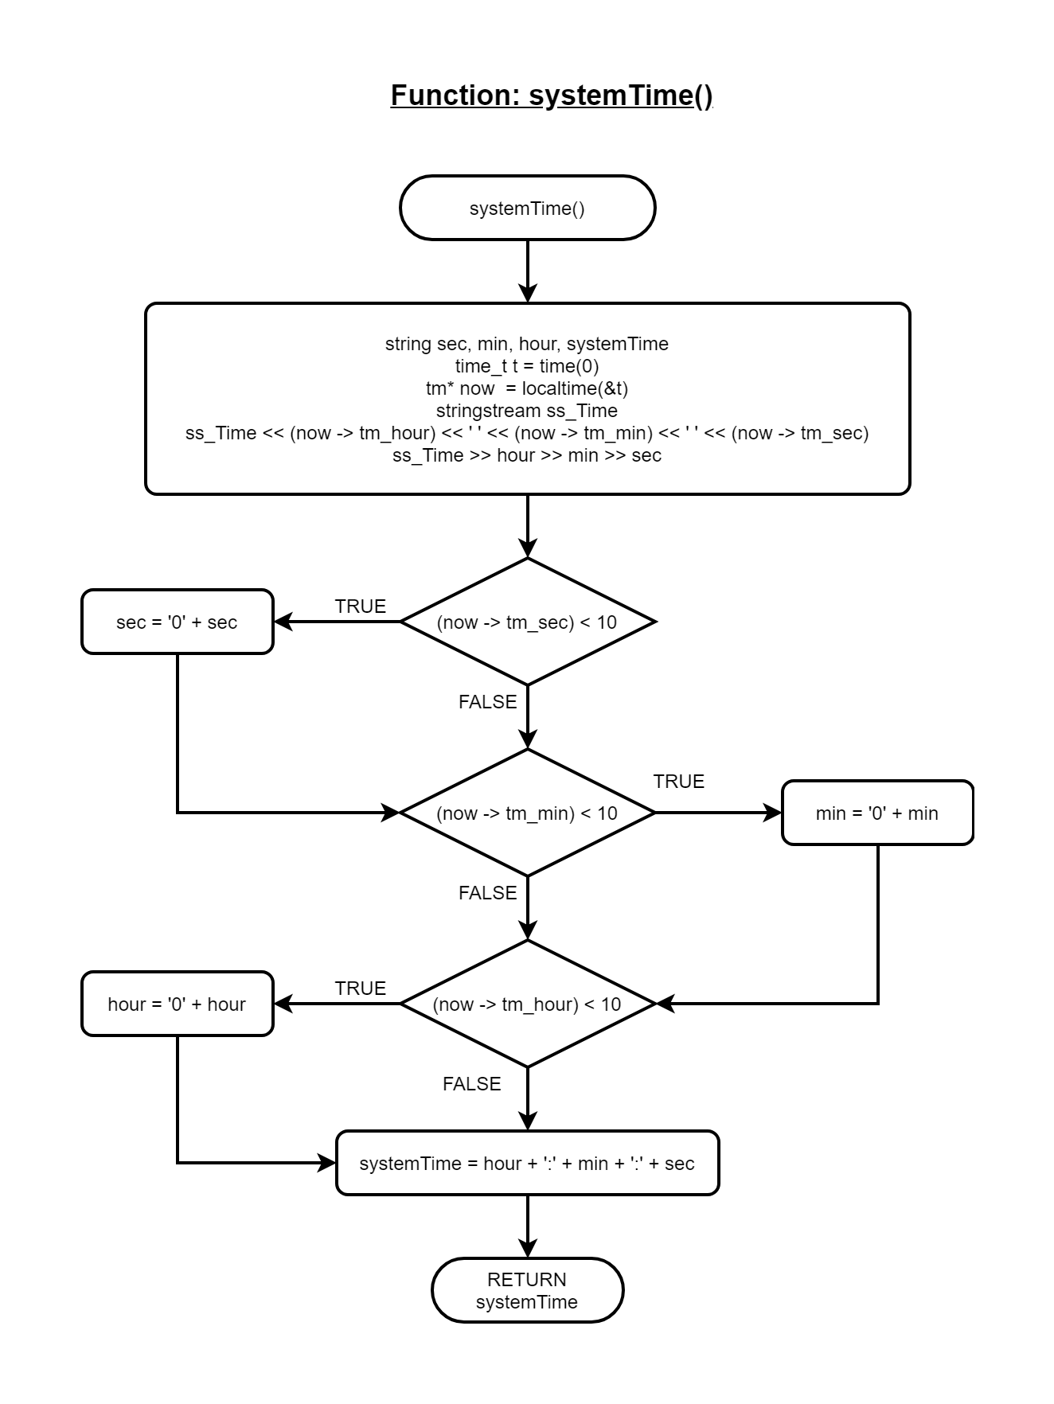Function: string systemTime()

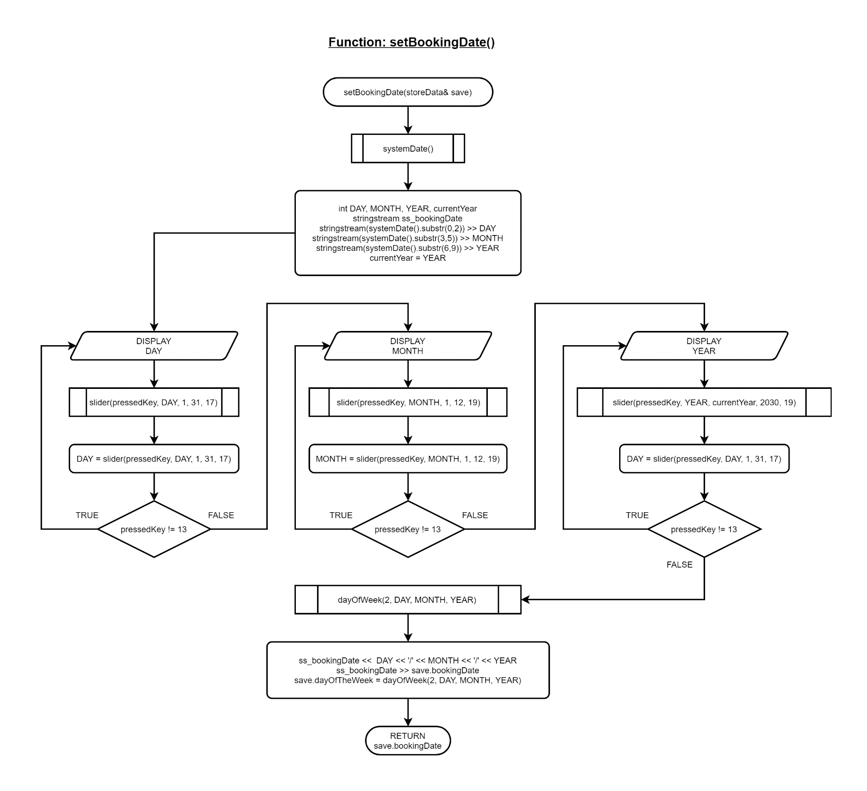Function: string setBookingDate(storeData& save)

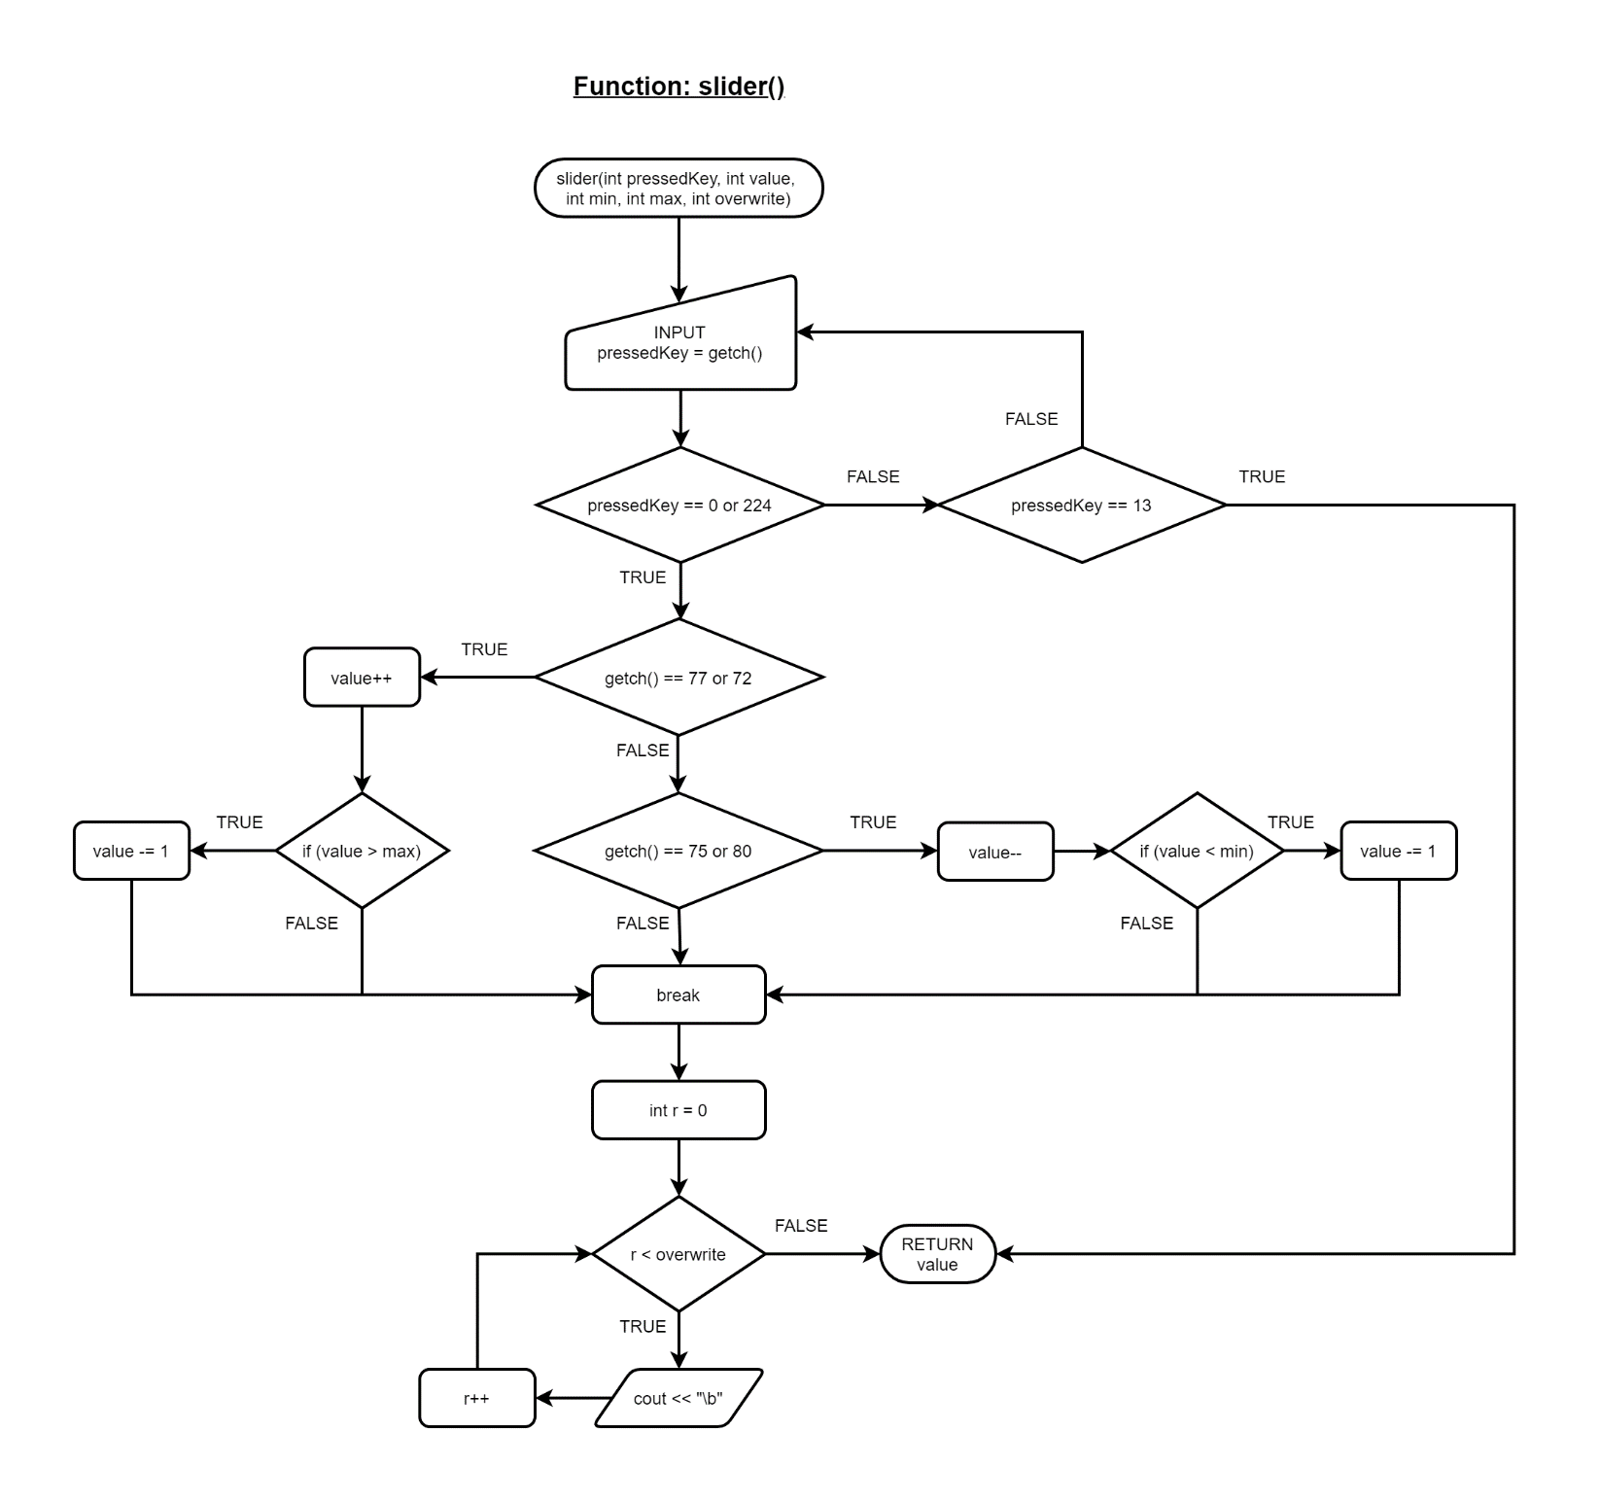Function: int slider(int& pressedKey, int value, int min, int max, int overwrite)

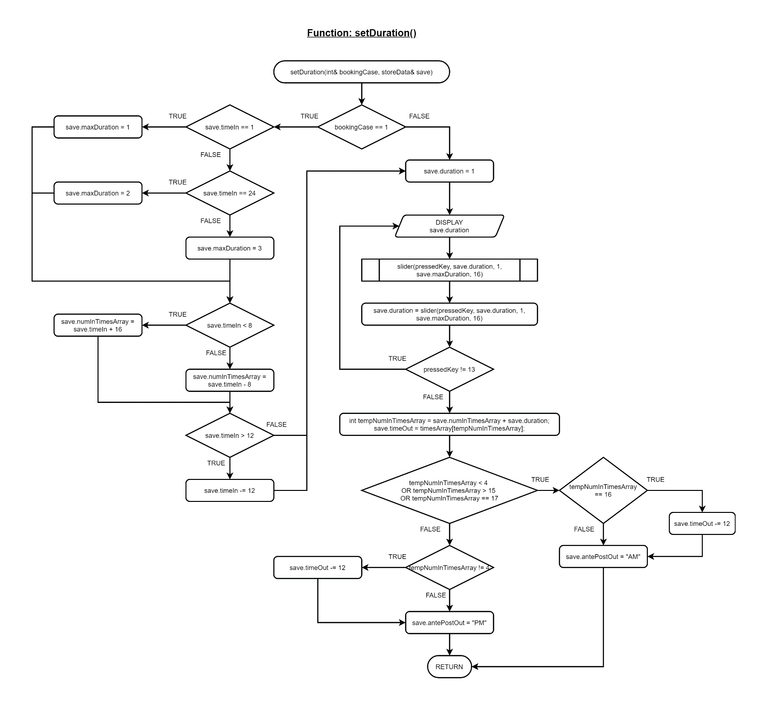Function: void setDuration(int& bookingCase, storeData& save)

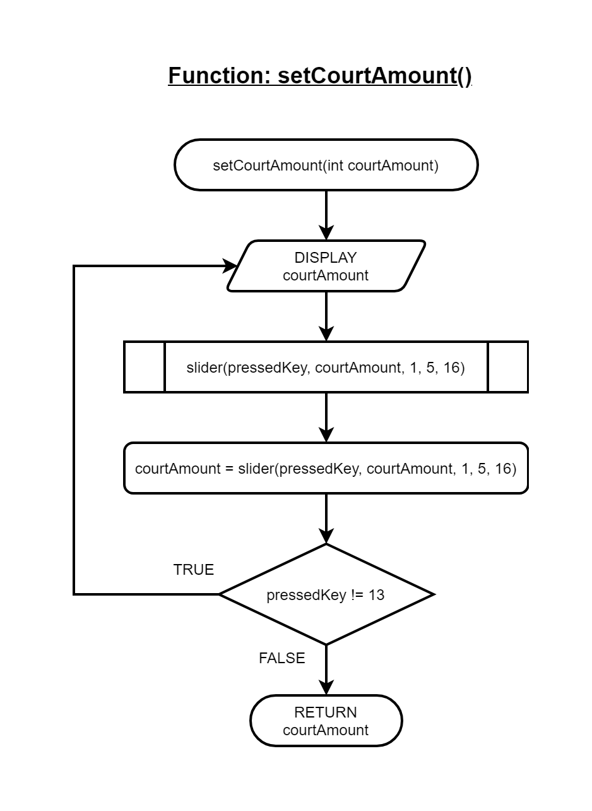Function: int setCourtAmount(int courtAmount)

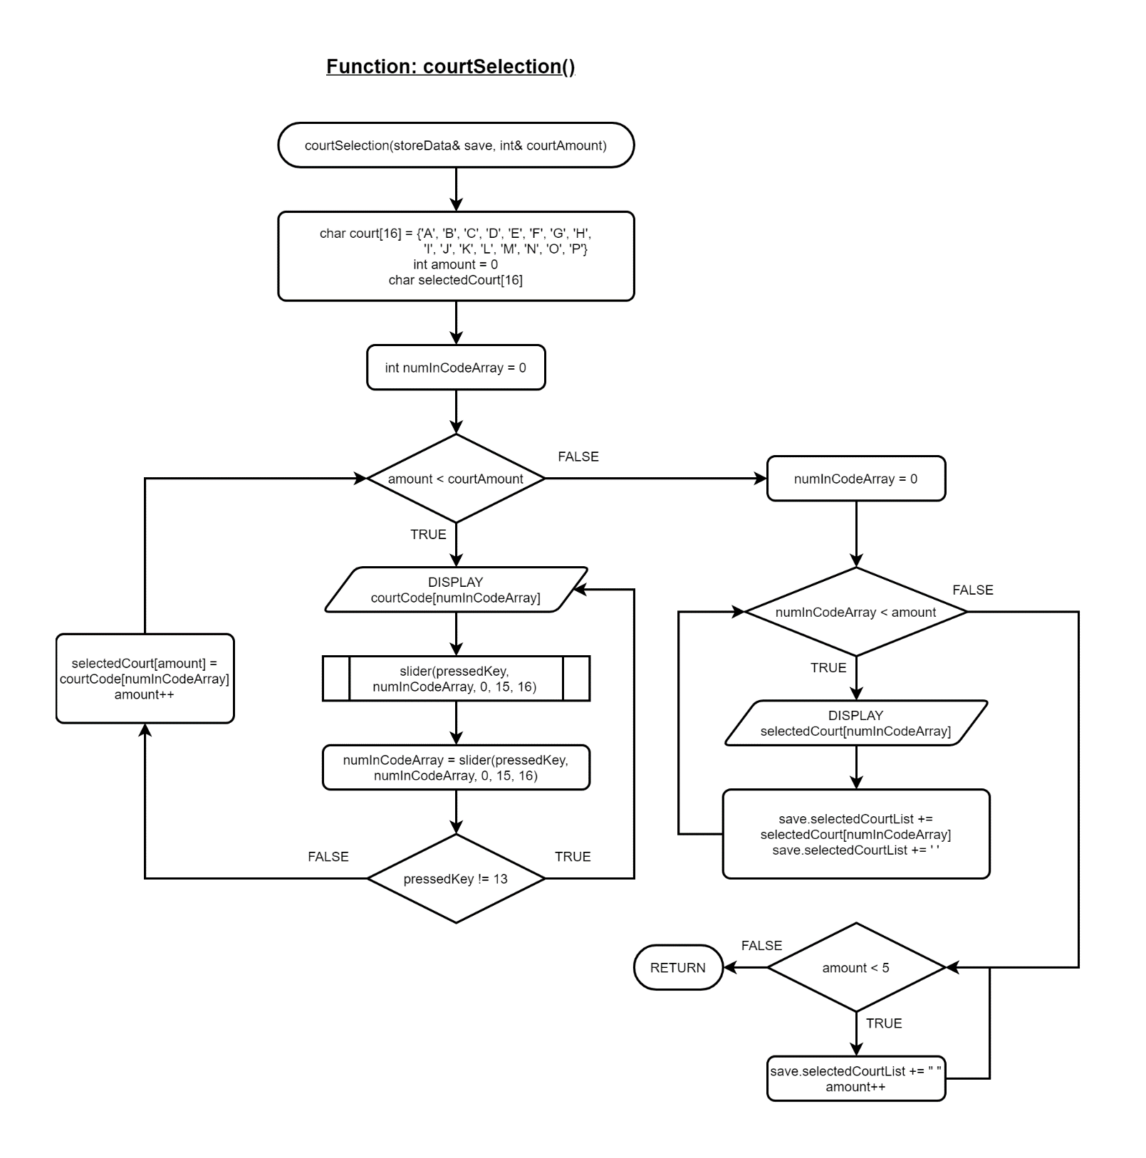Function: void courtSelection(storeData& save, int& courtAmount)

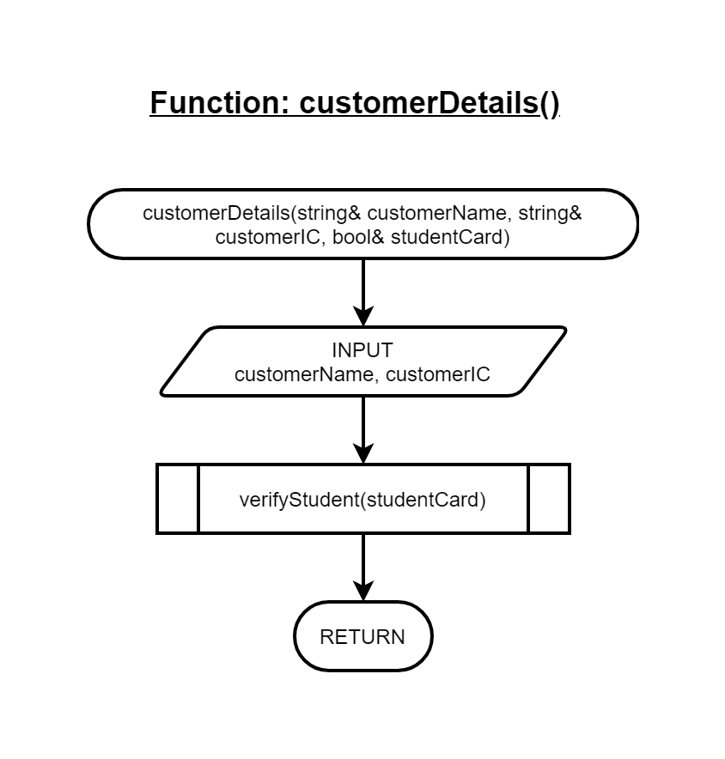Function: void customerDetails()

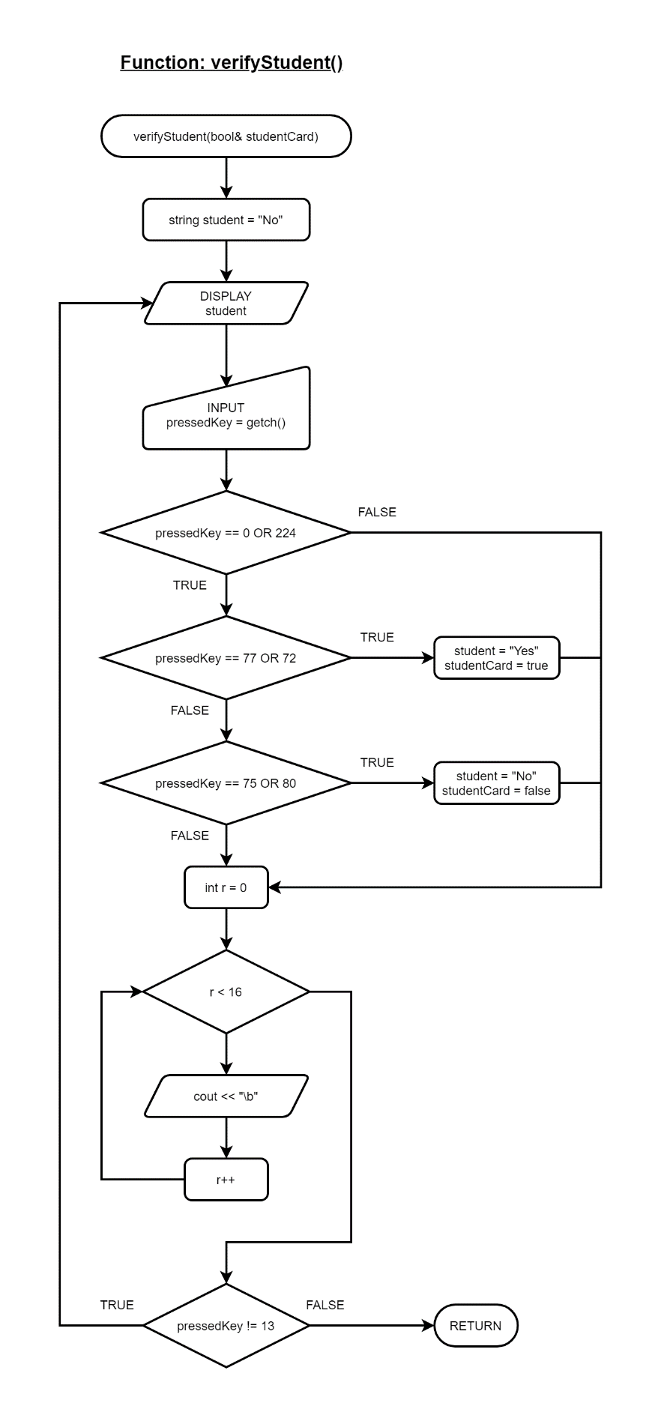Function: void verifyStudent(bool& studentCard)

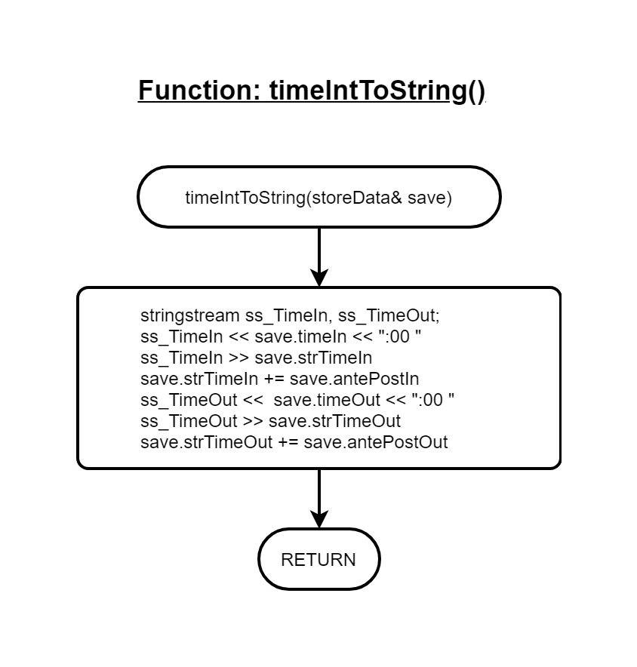Function: void timeIntToString(storeData& save)

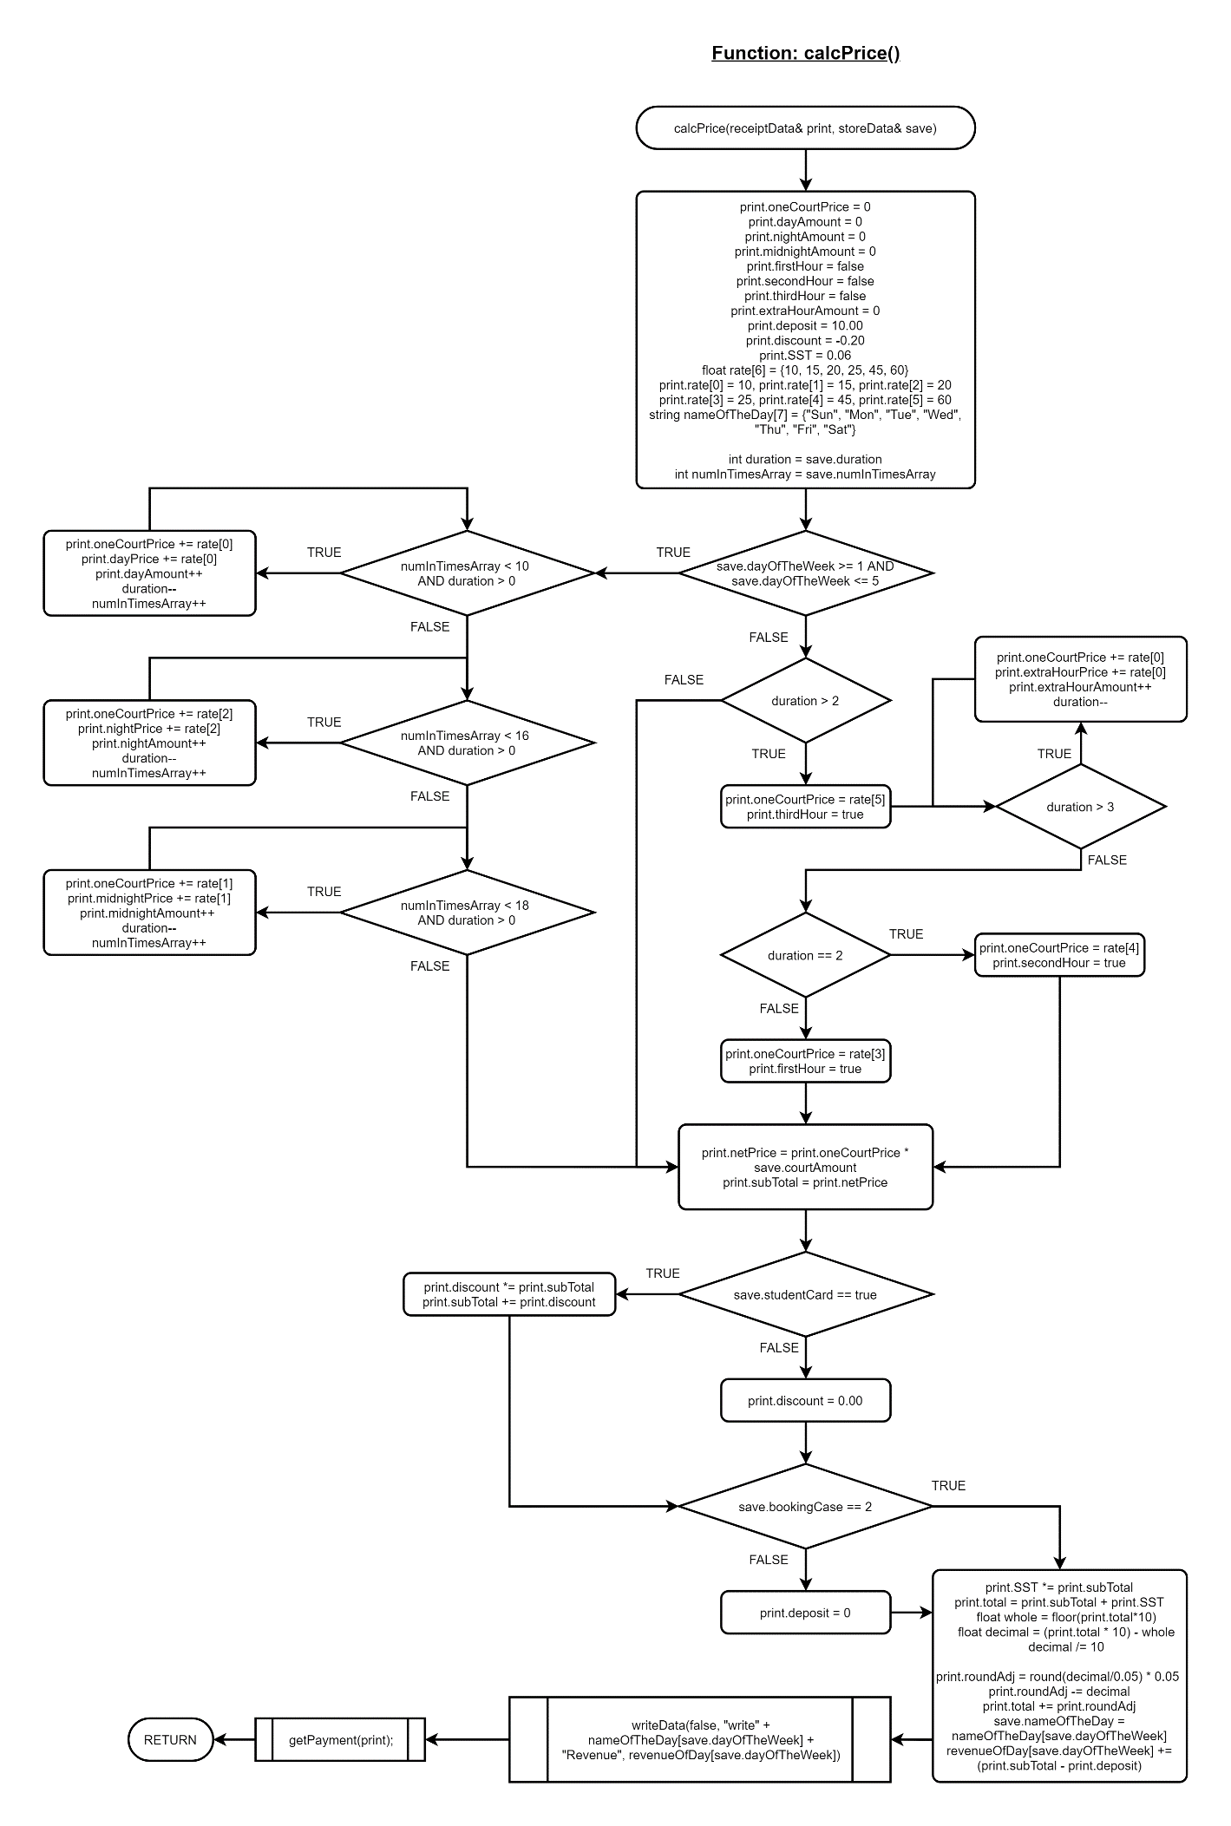Function: void calcPrice(receiptData& print, storeData& save)

Function: void writeData(bool targetAll, string target, float value)

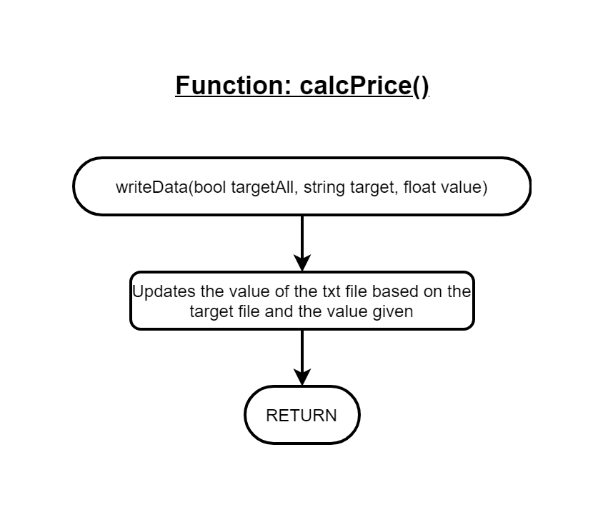

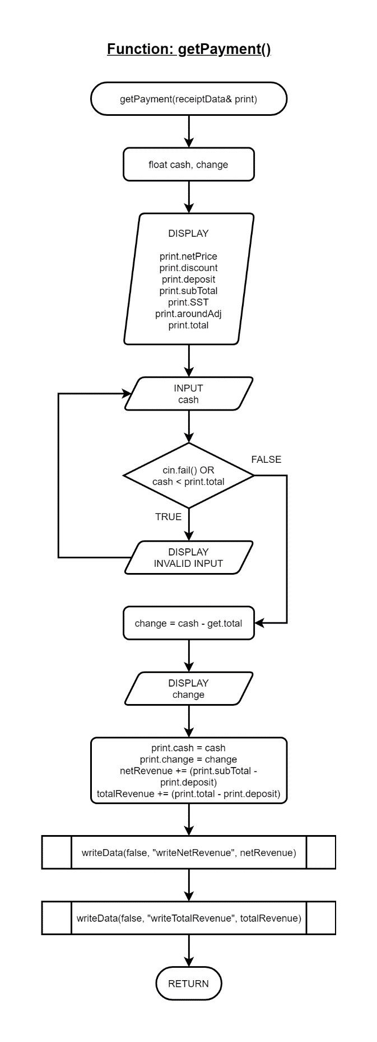Function: void getPayment(receiptData& print)

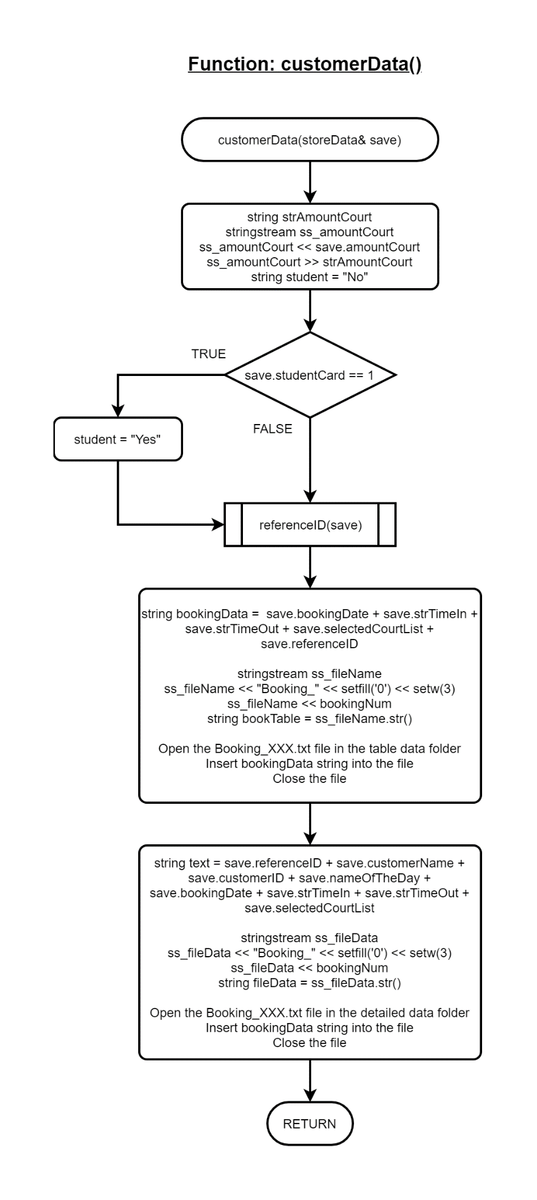Function: customerData(storeData& save)

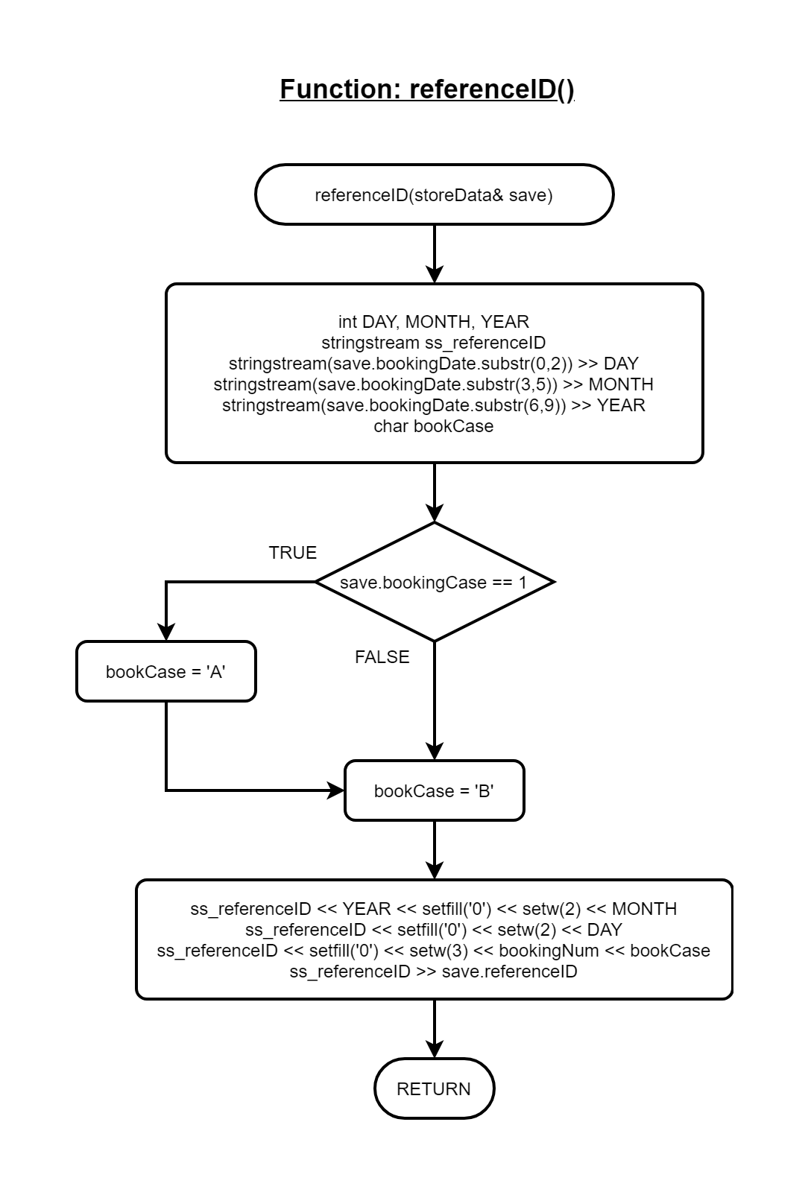Function: void referenceID(storeData& save)

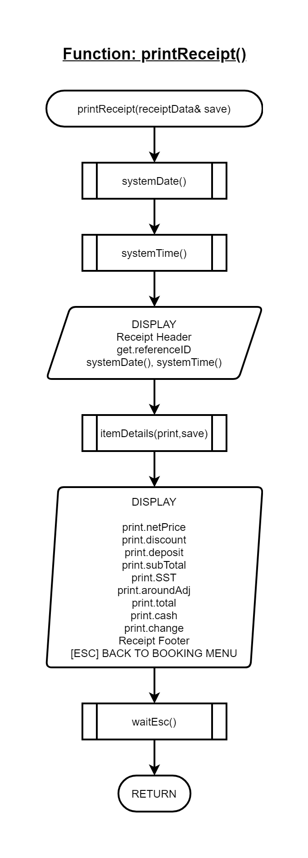Function: void printReceipt(receiptData& print, storeData& save)

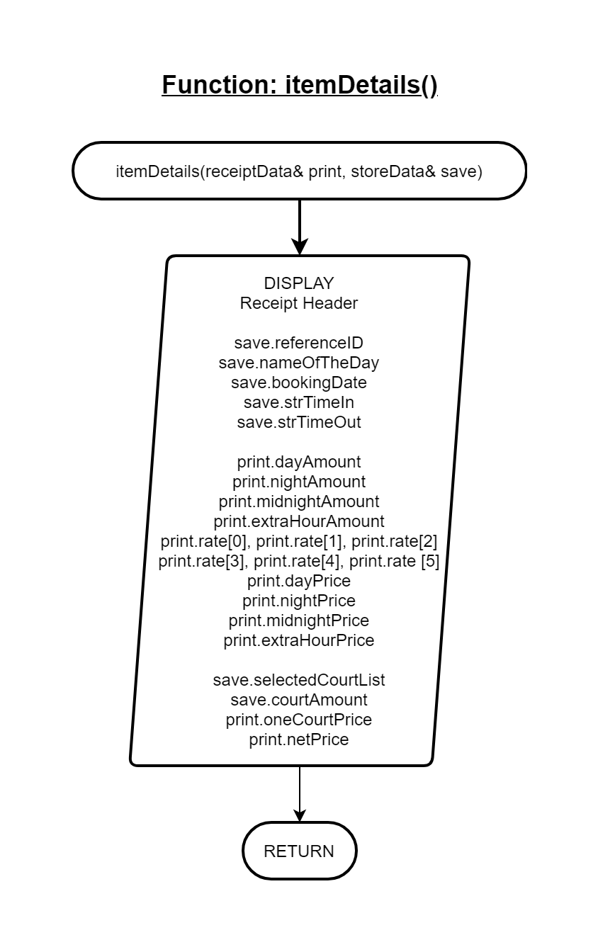Function: void itemDetails(receiptData& print, storeData& save)

Function: void currentBookings()

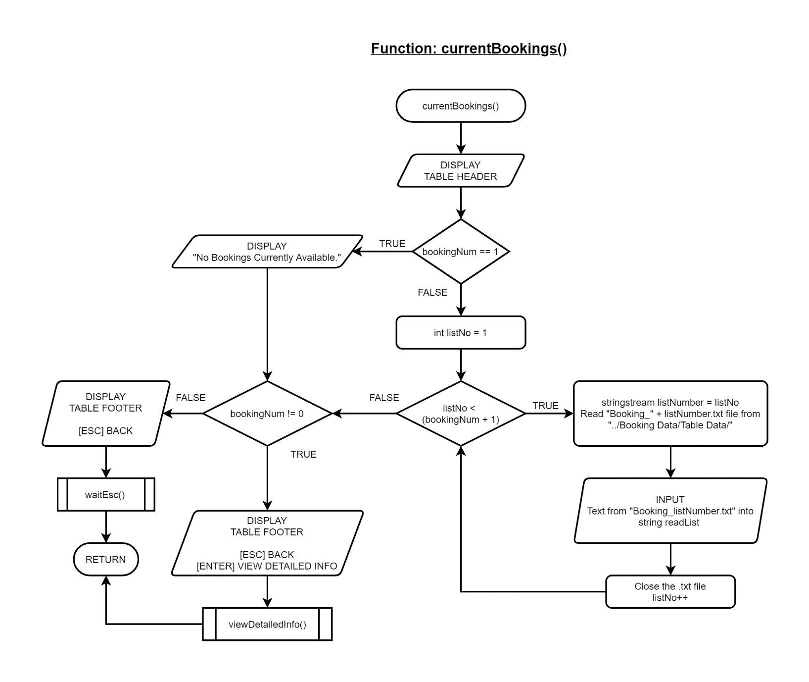

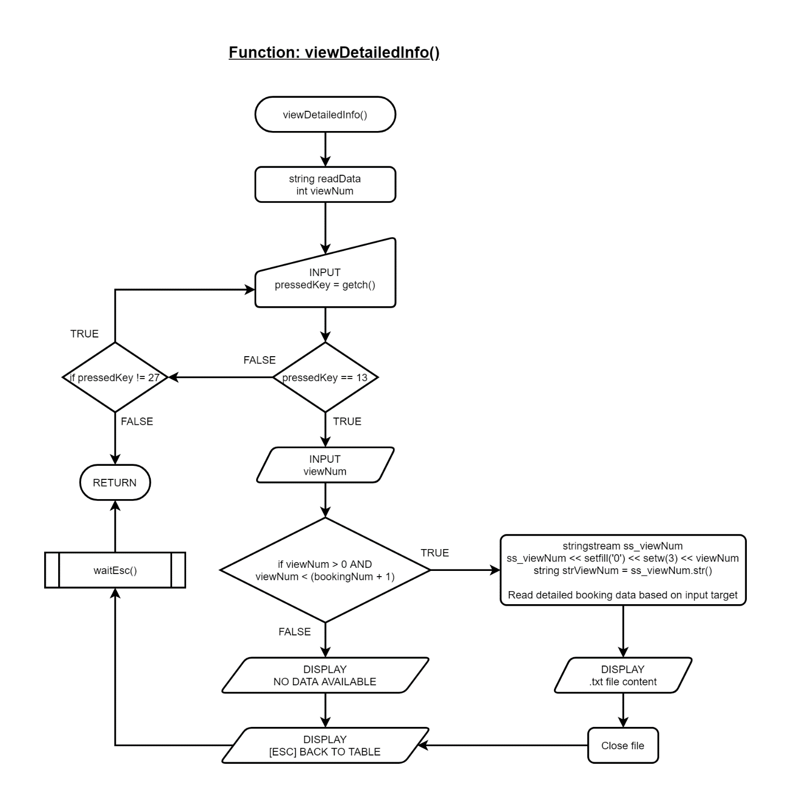Function: void viewDetailedInfo()

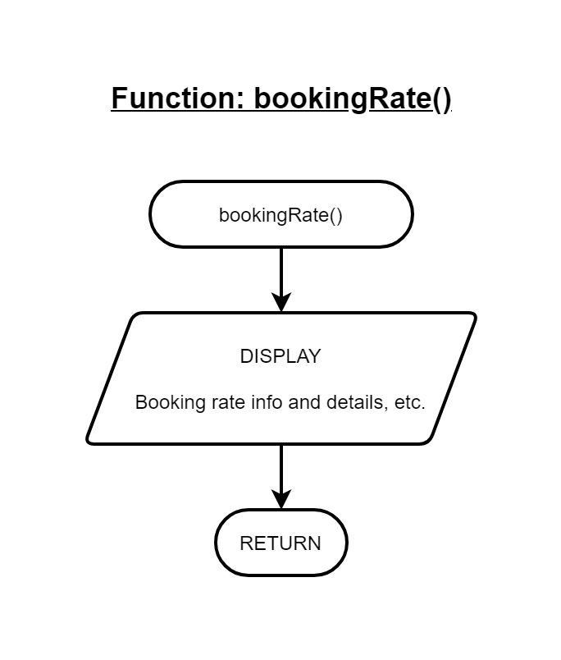Function: void bookingRate()

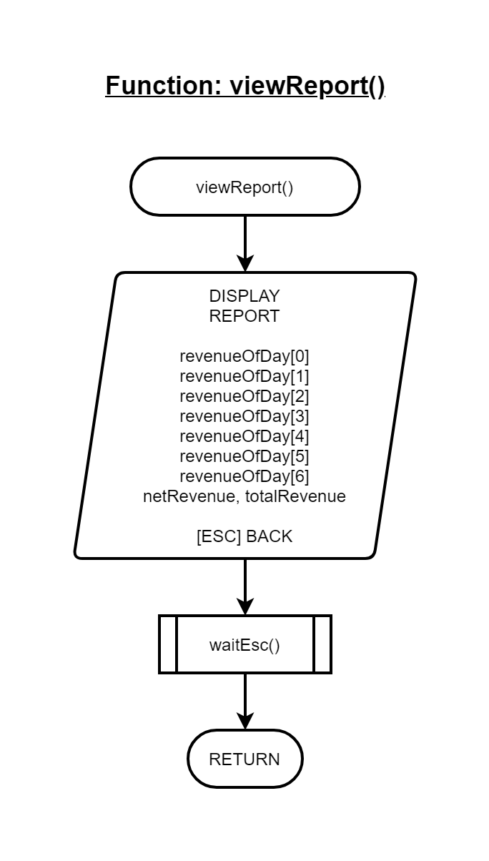Function: void viewReport()

Function: void 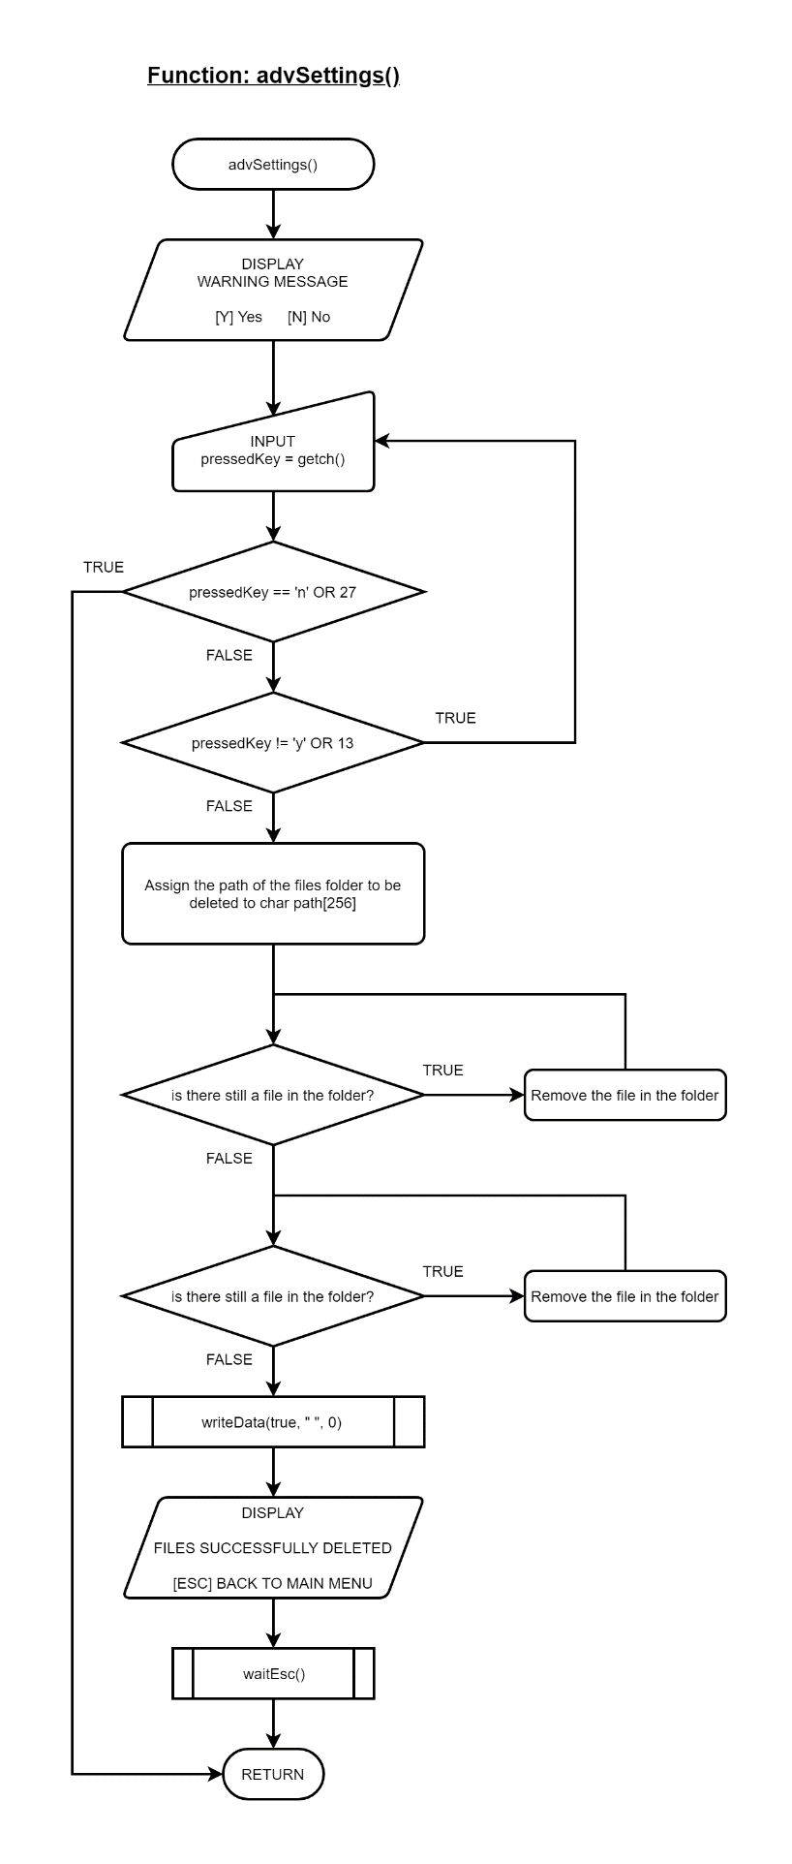advSettings()

Function endPrompt()

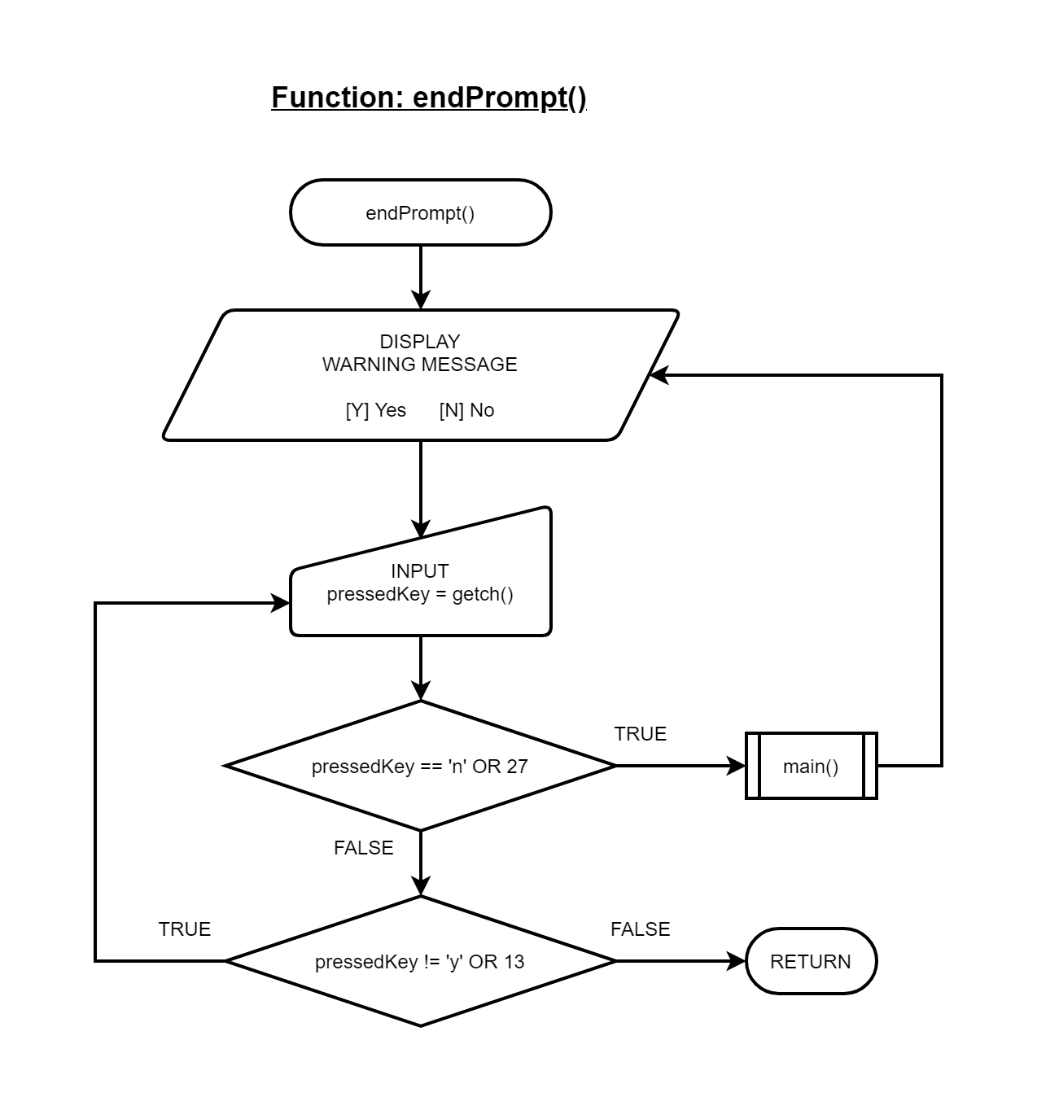

Function waitEsc()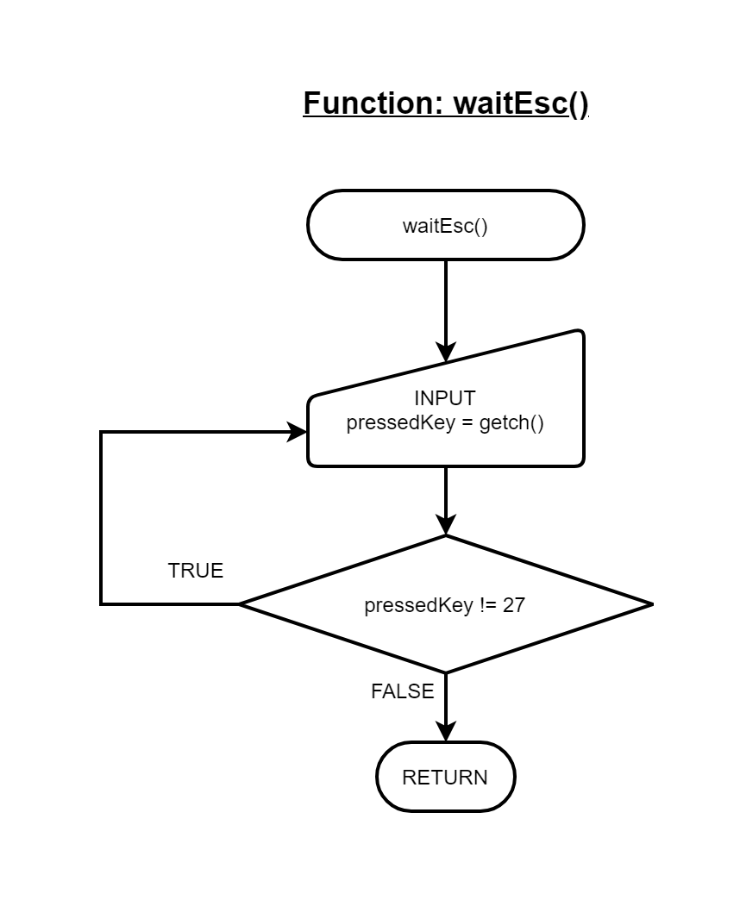

**OUTPUT SAMPLE**

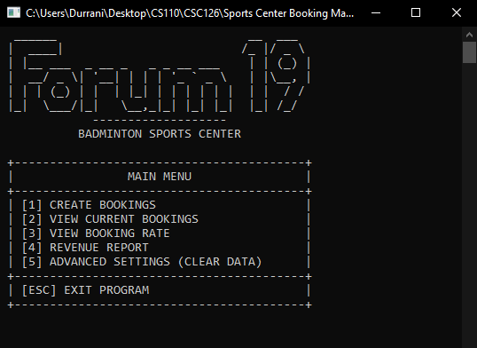Main Menu

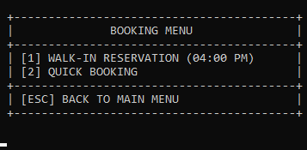Booking Menu

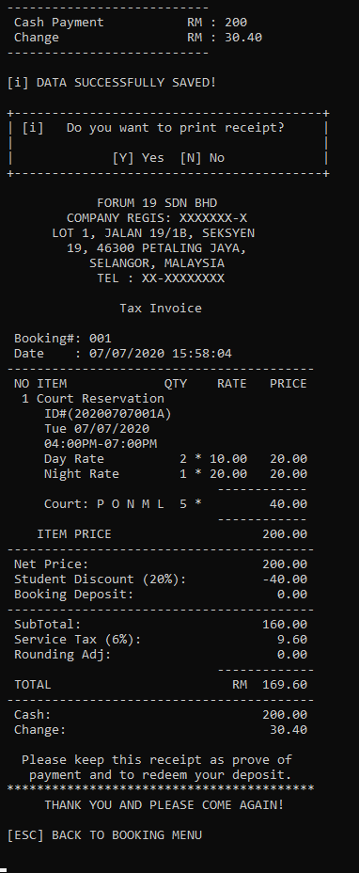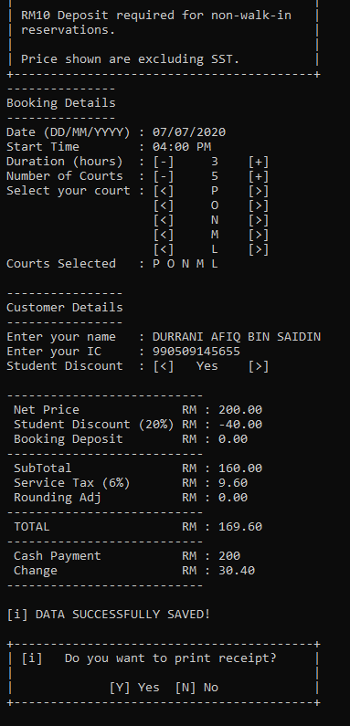Booking Form (Walk-In with receipt output)

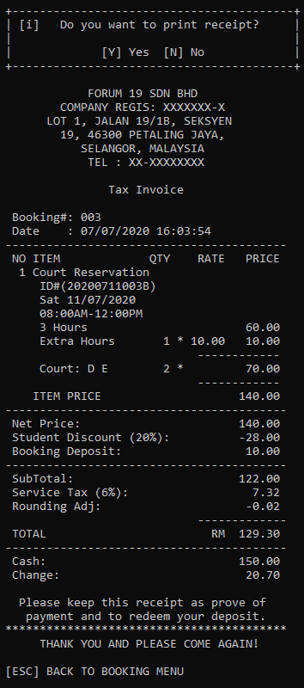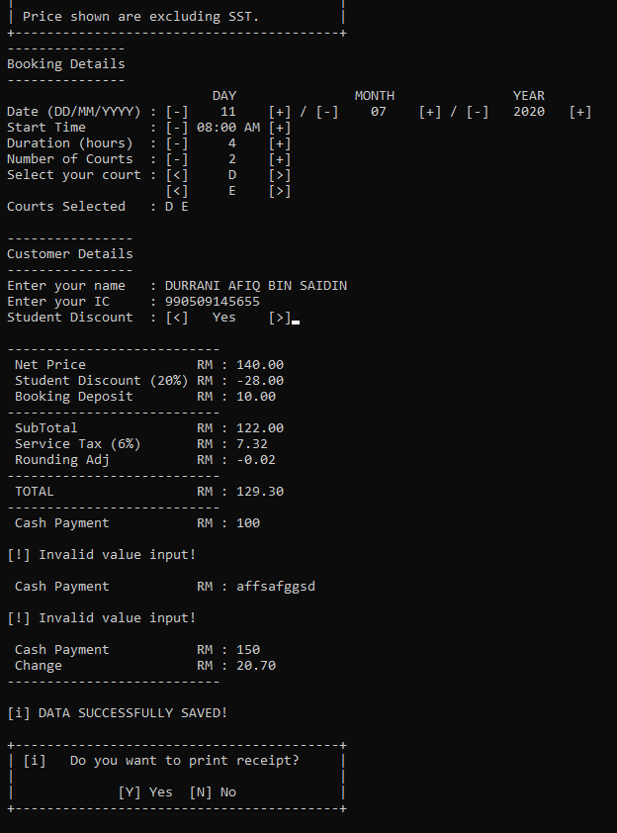Booking Form (Quick Booking with receipt output)

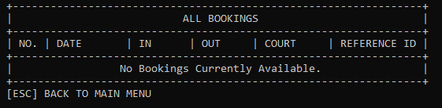View Current Bookings (Empty)

View Current Bookings (Filled)

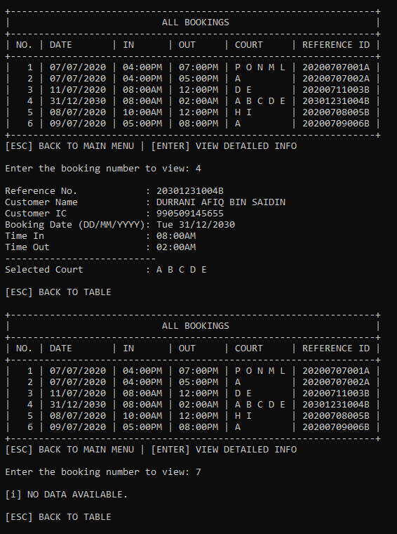

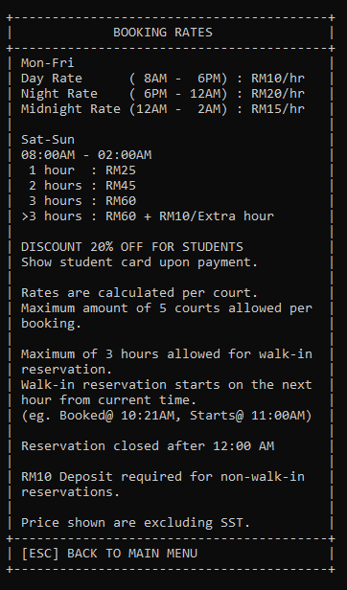View Booking Rates

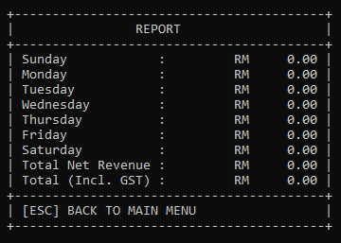View Report (Null)

View Report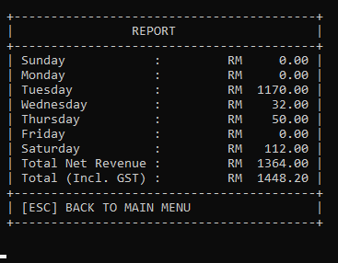

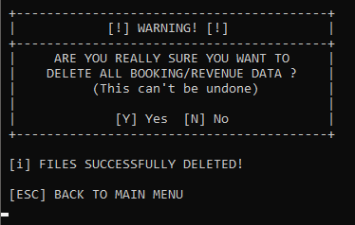Advanced Settings (Clearing Data)

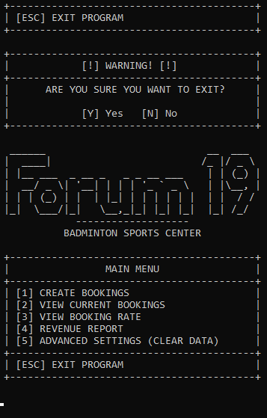End Prompt (Cancelled)

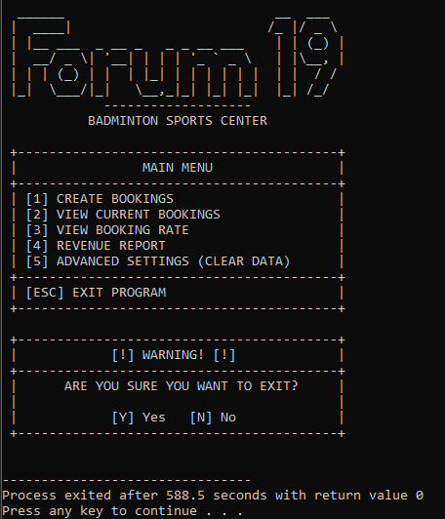End Prompt (Accepted/Returned 0)

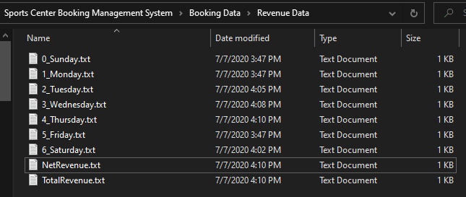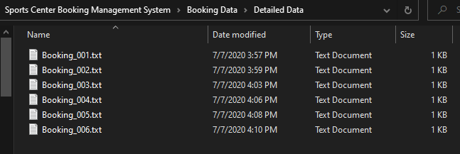Where data files are stored